**7D6N Wuxi-Hangzhou-Putuoshan-Shanghai**

**Period : Apr ,2020**

**Pax : 15+1Foc**

**Hotel : local 4**** or similar**

**Meal : normal meals**

**D1:Shanghai (--/--/--)**

Arrived in **Shanghai**, upon arrival, meet local services and tour guide**.**After dinner, transfer to hotel and have a rest.

**D2: Shanghai -Wuxi (B/L/D)**

Hotel breakfast,then transfer to **Wuxi,**visit **Lingshan Buddha, Buddhist Palace, Jiulong Guanyu, Zisha Museum,** back hotel for rest.

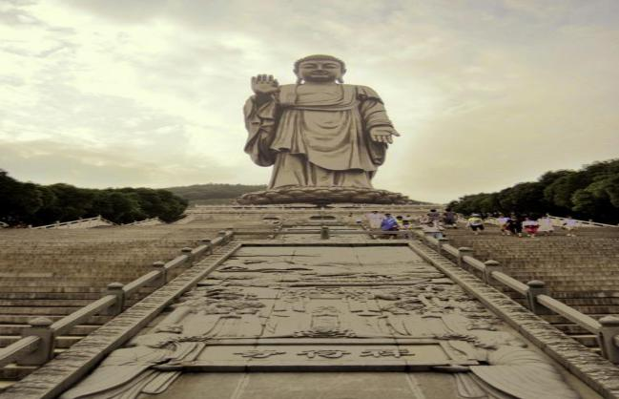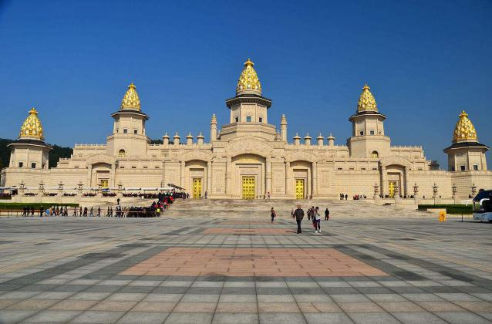**D3: Wuxi -Hangzhou (B/L/D)**

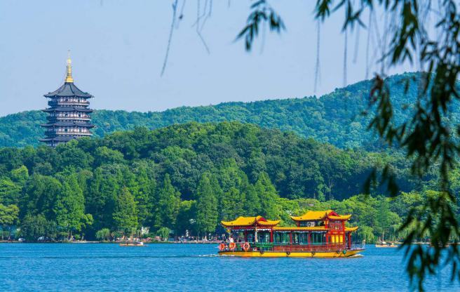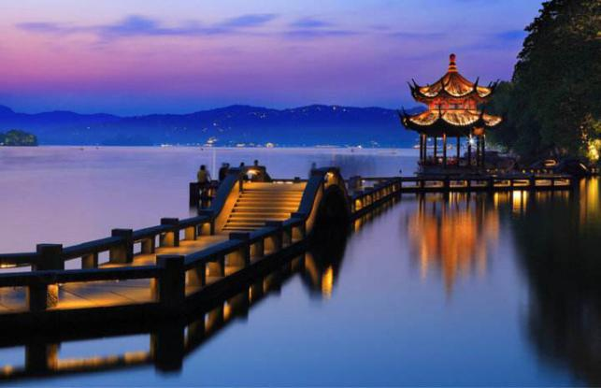After Breakfast in the hotel,then transfer to **Hangzhou** visit **Lihu Park, West Lake cruise, Changqiao Park, Out Looking appearance Leifeng Tower,** after dinner, then go to hotel to have a rest.

**D4: Hangzhou-Putuoshan (B/L/D)**

After Breakfast in the hotel,then transfer to **Putuoshan,**then visit **Meijiawu tea garden, speedboat to Putuo Mountain, visit Puji temple, Fayu Temple,**after dinner, then go to hotel to have a rest.

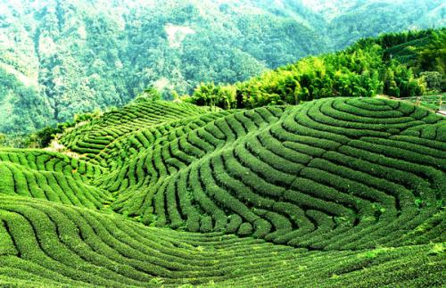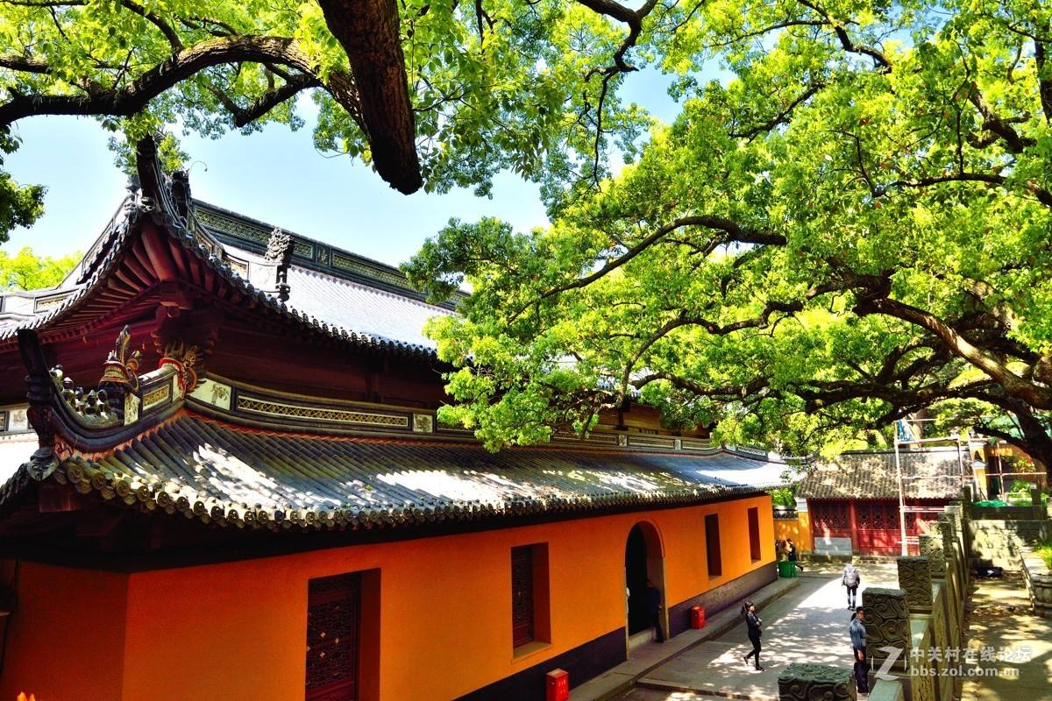

**D5: Putuoshan(B/L/D)**

After Breakfast in the hotel,then transfer to **Putuoshan,**then visit **Huiji Temple (up and down cable car), Nanhai Guanyin, Zizhulin.**After dinner, then go to hotel to have a rest.

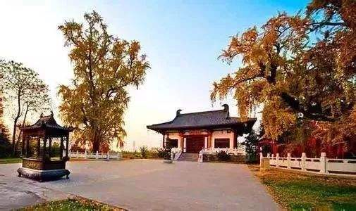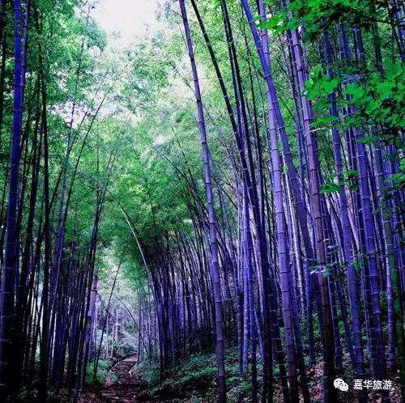**D6: Putuoshan-Shanghai(B/L/D)**

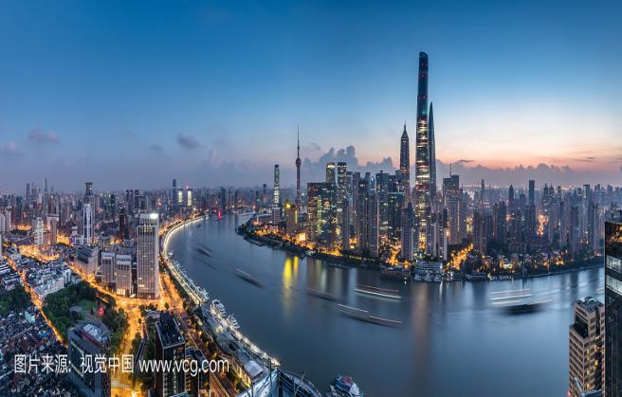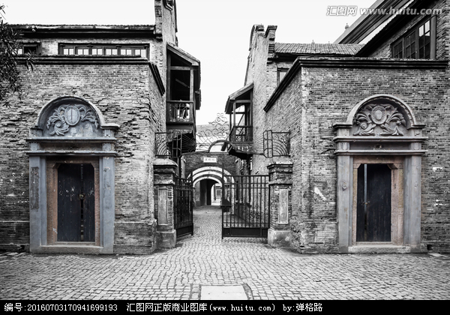After Breakfast in the hotel,then transfer to **Shanghai,**then visit **Nanjing Road Pedestrian Street, Starbucks baking workshop, Xintiandi, Shikumen, the Bund.** After dinner, then go to hotel to have a rest.

**D7:****Shanghai(B/--/--)**

After Breakfast in the hotel,then transfer to **airport,this is the end of tour.**

**Shopping stop:**

**Pearl, teapot, tea, latex, Yangshengtang, jewelry**

**Hotel 4 (local)**** or similar**

**Shanghai: Grace Select Hotel or similar**

[**https://hotels.ctrip.com/hotel/37073440.html#ctm_ref=www_hp_bs_lst**](https://hotels.ctrip.com/hotel/37073440.html#ctm_ref=www_hp_bs_lst)

**Wuxi:Wuxi International Hotel or similar**

## <https://hotels.ctrip.com/hotel/444051.html#ctm_ref=www_hp_bs_lst>

**Hangzhou:Blossom Tao Hotel or similar**

[**https://hotels.ctrip.com/hotel/29550567.html#ctm_ref=www_hp_bs_lst**](https://hotels.ctrip.com/hotel/29550567.html#ctm_ref=www_hp_bs_lst)

**Putuoshan:Citic Putuo Hotel or similar**

[**https://hotels.ctrip.com/hotel/436120.html#ctm_ref=www_hp_bs_lst**](https://hotels.ctrip.com/hotel/436120.html#ctm_ref=www_hp_bs_lst)

**(Putuoshan Hotel + 15USD on Friday/PAX and + 60USD on Saturday/PAX)**

|  |  |  |  |  |
| --- | --- | --- | --- | --- |
| **PAX**  **(Adult)** | **4 STAR (per pax)** | | | |
| **TWN（USD）** | **SGL SUPL（USD）** | **CWB**  **(USD)** | **CNB**  **(USD)** |
| **15+1Foc** | **365** | **150** | **365** | **295** |

**The above quotation included:**

1. Transfer in/out

2. Meals

3. Indonesian speaking guide and entrance fee

4. Accommodate in 4 star hotel

5. Free 1 Bottle of water /Pax/day

**The above quotation excluded:**

1. International flight ticket and airport tax

2. Tips for the guide and driver $4/pax/day.(above 10 pax)

3. Tips for potter, waitress & Luggage’s fee

4. Personal consumptions & expenses (laundry, phone, mini bar, etc)

REMARKS

* The sequence of the tour program may be re-arranged by local tour operators as deemed necessary

* FOC is only for Tour Leader. Tour Leader without professional leader card can’t get fully free of charge. Need to pay entrance fee and another needed expense by her/himself.

* Price is not available at Chinese National Holiday/Festival or big events (negotiable)

* Price can be change depends on situations, conditions & terms (negotiable)

* Price of the flight can be change depends on situation (negotiable)

* The above rates are unavailable for groups of students, university, travel agent family / staff, airline staffs